APPIUM Architecture

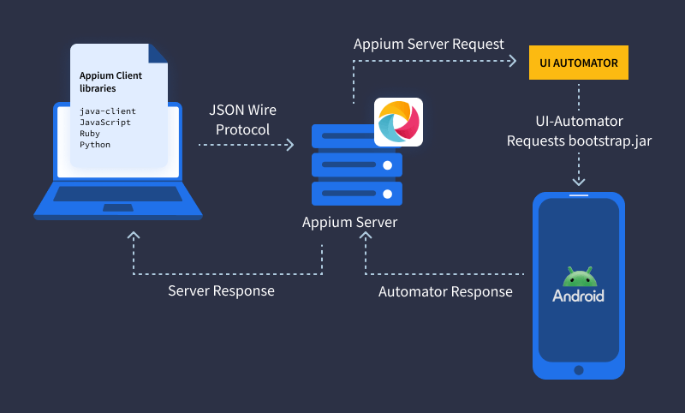

1. Appium Client Library - Provides bindings for various languages (Java, Python, etc.). Translates test commands to HTTP REST API requests.
2. Appium Server - A Node.js server that receives commands from the client and routes them to the appropriate driver (Android or iOS).
3. Appium Drivers - Platform-specific automation engines:
- UiAutomator2 (Android)
- XCUITest (iOS)
- Windows Driver (Windows Apps)
4. Mobile Device / Emulator - Executes the actual commands like tap, swipe, input text, etc., through the connected automation driver.
5. Appium Inspector (Optional) - GUI tool to inspect app elements and generate locators (similar to browser developer tools). Useful for scripting.

Flow of Execution
- Test Case Execution Starts → Using Java + TestNG or Cucumber.

- Appium Client Library converts test steps into JSON format.

- HTTP Requests are sent to Appium Server (typically localhost:4723).

- Appium Server routes the request to the platform-specific Driver.

- Driver interacts with the OS-level automation engine (e.g., UiAutomator2 or XCUITest).

- Automation Engine performs action on the device/app.

- Response is sent back from device → driver → server → client → test report.

Key Features of Appium Architecture
- Cross-platform testing (Write once, run on iOS/Android).

- Language agnostic – supports Java, Python, C#, etc.

- Supports native, hybrid, and mobile web apps.

- Based on client-server model using REST API.

- No need to recompile or modify the app.

Appium Concepts

Client/Server Architecture
- Appium is at its heart a webserver that exposes a REST API.
- It receives connections from a client, listens for commands, executes those commands on a mobile device, and responds with an HTTP response representing the result of the command execution.
- The fact that we have a client/server architecture opens up a lot of possibilities: we can write our test code in any language that has a http client API, but it is easier to use one of the Appium client libraries.
- We can put the server on a different machine than our tests are running on.
- We can write test code and rely on a cloud service like Sauce Labs to receive and interpret the commands.

Session
- Automation is always performed in the context of a session.
- Clients initiate a session with a server in ways specific to each library, but they all end up sending a POST /session request to the server, with a JSON object called the 'desired capabilities' object.
- At this point the server will start up the automation session and respond with a session ID which is used for sending further commands.

Desired Capabilities
- Desired capabilities are a set of keys and values (i.e., a map or hash) sent to the Appium server to tell the server what kind of automation session we're interested in starting up.
- There are also various capabilities which can modify the behavior of the server during automation. For example, we might set the platformName capability to iOS to tell Appium that we want an iOS session, rather than an Android one. Or we might set the safariAllowPopups capability to true in order to ensure that, during a Safari automation session, we're allowed to use JavaScript to open up new windows. See the capabilities doc for the complete list of capabilities available for Appium.

Appium Server
Appium is a server written in Node.js. It can be built and installed from source or installed directly from NPM.

Appium Clients
There are client libraries (in Java, Ruby, Python, PHP, JavaScript, and C#) which support Appium's extensions to the WebDriver protocol. When using Appium, you want to use these client libraries instead of your regular WebDriver client. You can view the full list of libraries here.

Appium.app, Appium.exe
There exist GUI wrappers around the Appium server that can be downloaded. These come bundled with everything required to run the Appium server, so you don't need to worry about Node. They also come with an Inspector, which enables you to check out the hierarchy of your app. This can come in handy when writing tests.

